1. Context Free Grammars
   1. W contains at least 3 1’s
      1. S->T1T1T1T
      2. T->0T|1T|λ
   2. Absolute value of w is even
      1. S-> 0S0|1S1|λ
   3. i=j or i=k
      1. S->XY|W
      2. X->aXb|λ
      3. Y-cY|λ
      4. W->aWc|λ
      5. z->bZ|λ
2. Context free w/ rules of regular expressions
   1. T = {a, b, (, ), +, *, Ø}.
      1. By rule 1, Ø, a, b are regular expressions, the production for this would be:
      2. S->Ø|a|b
      3. By rule 2, if r1 and r2 are regular expressions, then r1r2 is a regular expression as well. Productions would be:
      4. S->SS
      5. Continuing in this way, the production set is as follows:
      6. S-> a|b|(S)|S+S|SS| S*
      7. So for our CFG G={V,T,S,P}
      8. Where V= {S}
      9. T = {a, b, (, ), +, *, Ø}.
      10. S = start variable
      11. P is production set above.
      12. Derivation is:
      13. S->S*
      14. ->(S)*
      15. ->(S+S)*
      16. ->(a+S)*
      17. ->(a+b)*
3. Consider the following grammar
   1. Language
      1. S->SS
      2. S->AAA
      3. S->λ
      4. A->aA
      5. A->Aa
      6. A->b
      7. Taking 1 production:
      8. S->SS
      9. S->AAAS
      10. S->AAA
      11. Taking 4 production:
      12. A->aA
      13. A->aAa
      14. A->aaAa
      15. A->aaba
      16. From the above derivations, our language ends up as:
      17. L={λ, a*, a*ba*}
   2. Left most derivation:
      1. **S->abbaba**
      2. S->AAA
      3. S->aAAA
      4. S->abAA
      5. S->abbA
      6. S->abbaA
      7. S->abbaAa
      8. S->abbaba
   3. Grammar is ambiguous through two trees (Ignore the lambdas):
      1. Tree 1:
      2. 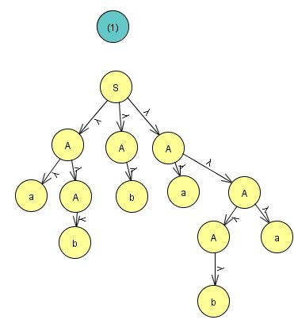
      3. Tree 2:
      4. 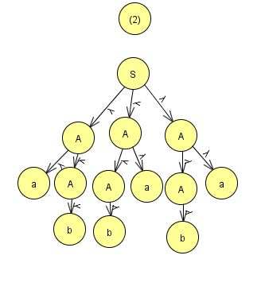
   4. If regular, give regular grammar:
      1. S1-> a|b|λ
      2. S2-> aS1a
      3. S3->aS2b
      4. S4->b
4. Find an s-grammar
   1. G = ({S, S1, B}, {a, b}, S, P)
   2. We have the following productions :
   3. S ->aS1B,
   4. S1 -> aS1B|b
   5. B -> b
5. Let L = {a^n b^n n>=0)
   1. Show that L^2 is context free
      1. G = ({S}.{a,b},p,s)
      2. S->ab
      3. S->aabb->aSb
      4. S->aaabbb->aSb
      5. Thus, this is a context free language
   2. Show that L* is context free
      1. L is context free, and we must now prove l* is the same, l* is created by:
      2. S->S1 S | λ
      3. S1-> aS1b|λ
      4. L is generated by G=(v,t,p,s)
      5. Define cfg, G that generates the L* as:
      6. G=({S},T,{S->SS1|λ} , S}
      7. Each word is in either λ or sequence of word is in g
      8. So every word of l* can be generated by our G